Understanding Linear Regression: A Full Guide
Linear Regression is a fundamental statistical method used to model the relationship between two continuous variables by fitting a linear equation to observed data. In simpler terms, it's about drawing the "best fit" straight line through a set of data points to predict future outcomes.

Best Fit Line in Linear Regression
In linear regression, the best-fit line is the straight line that most accurately represents the relationship between the independent variable (input) and the dependent variable (output). It is the line that minimizes the difference between the actual data points and the predicted values from the model.

Goal of the Best-Fit Line
The goal of linear regression is to find a straight line that minimizes the error (the difference) between the observed data points and the predicted values. This line helps us predict the dependent variable for new, unseen data.

1. The Best Fit Line: y = mx + b
At the heart of linear regression is the equation of a straight line:
y(Dependent Variable): The variable we want to predict or explain (e.g., house price).
x(Independent Variable): The variable we use to predict x (e.g., square footage of a house).
m (Slope)/weight: This determines the steepness of the line. It tells us how much y changes for every one-unit change in x. A positive slope means y increases with x, while a negative slope means y decreases with x.
b (Y-intercept)/bias: This is the point where the line crosses the y-axis (i.e., the value of y when x is 0).
The goal is to find the unique m and b values that make this line best represent the relationship in our data.

Type of linear Regression

Simple Linear Regression
Simple linear regression is used when we want to predict a target value (dependent variable) using only one input feature (independent variable). It assumes a straight-line relationship between the two.
Formula
y^​=θ0​+θ1​x
Where:
- y^​​ is the predicted value
- X is the input (independent variable)
- θ0​ is the intercept (value of ​y^​​ when x=0)
- θ1​​ is the slope or coefficient (how much y^​​ changes with one unit of x)

Example:
Predicting a person’s salary (y) based on their years of experience (x).

2. Multiple Linear Regression
Multiple linear regression involves more than one independent variable and one dependent variable. The equation for multiple linear regression is:
y^​=θ0​+θ1​x1​+θ2​x2​+⋯+θn​xn​
where:
- y^​​ is the predicted value
- x1,x2,…,xn​ are the independent variables
- θ1,θ2​,…,θn​ are the coefficients (weights) corresponding to each predictor.
- θ0​ is the intercept.
The goal is to find the best-fit line that predicts Y accurately for given inputs X.
Use Cases
- Real Estate: Predict property prices using location, size and other factors.
- Finance: Forecast stock prices using interest rates and inflation data.
- Agriculture: Estimate crop yield from rainfall, temperature and soil quality.
- E-commerce: Analyze how price, promotions and seasons affect sales.

How to find out best fit Line
Least Squares - > To find the best-fit line, we use a method called Least Squares. The idea behind this method is to minimize the sum of squared differences between the actual values (data points) and the predicted values from the line. These differences are called residuals.
The formula for residuals is:
Residual=yᵢ−y^​ᵢ
Where:
- yᵢ is the actual observed value
- y^​ᵢ is the predicted value from the line for that xᵢ
The least squares method minimizes the sum of the squared residuals:
Sumofsquarederrors(SSE)=Σ(yᵢ−y^ᵢ)²
This method ensures that the line best represents the data where the sum of the squared differences between the predicted values and actual values is as small as possible.

Finding m and b: The Core Techniques
There are two primary methods to determine the optimal slope (m) and intercept (b): Ordinary Least Squares (OLS) and Gradient Descent.

A. Ordinary Least Squares (OLS) - The Direct Method
OLS is an analytical method that directly calculates the values of m and b that minimize the Sum of Squared Errors (SSE). The SSE is the sum of the squares of all the residuals. By squaring the errors, we ensure that both positive and negative errors contribute to the total error, and larger errors are penalized more heavily.
The objective function to minimize is:
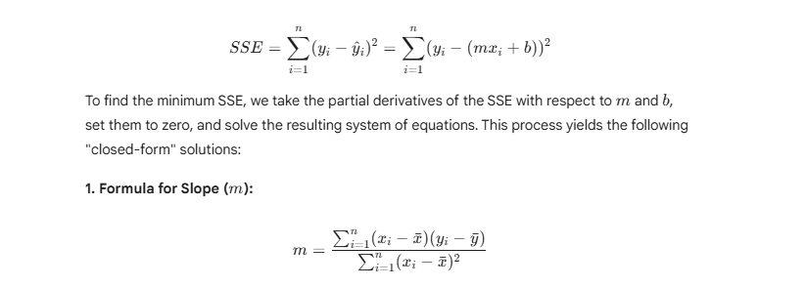
2. Formula for Intercept (b):
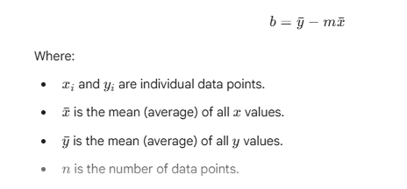
Advantages of OLS:
Provides an exact, mathematically optimal solution.
Fast for smaller datasets.
Disadvantages of OLS:
Can become computationally intensive and slow for very large datasets (millions of data points or more) due to matrix operations involved in more complex forms.

B. Gradient Descent (GD) - The Iterative Method
Gradient Descent is an iterative optimization algorithm used to find the minimum of a function (in our case, the SSE or Mean Squared Error). It's particularly useful for very large datasets where OLS becomes inefficient.
Imagine you're blindfolded on a mountain and want to reach the lowest point (the minimum error). You would feel the slope around you and take a small step in the steepest downward direction. You repeat this until you can't go down any further.

How it works:
- Start with random values for slope and intercept.
- Calculate the error between predicted and actual values.
- Find how much each parameter contributes to the error (gradient).
- Update the parameters in the direction that reduces the error.
- Repeat until the error is as small as possible.
This helps the model find the best-fit line for the data.

How Does Gradient Descent Work in Linear Regression?
Lets see various steps involved in the working of Gradient Descent in Linear Regression:
1. Initializing Parameters: Start with random initial values for the slope (m) and intercept (b).
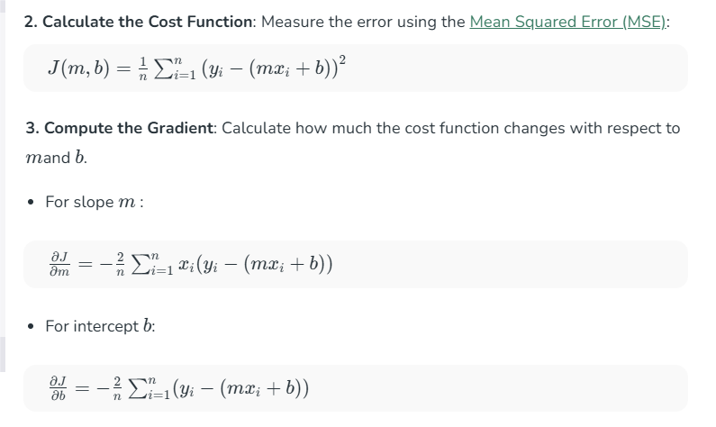
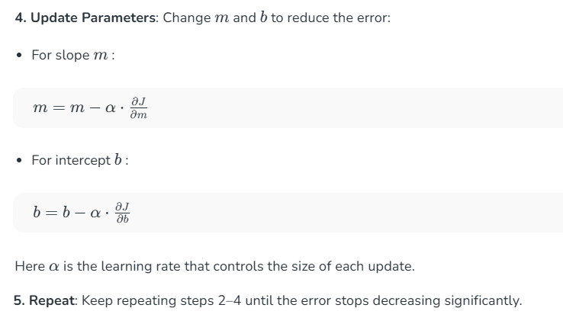


Error function

Mean Absolute Error (MAE)
Explanation: MAE is the average of the absolute differences between the actual and predicted values. It measures the average magnitude of the errors without considering their direction.
Advantages:
Easy to interpret: Directly tells you the average error in the same units as the dependent variable. E.g., "On average, our prediction is off by X dollars."
Robust to outliers: Since it uses absolute values, large errors from outliers don't have an extremely disproportionate effect compared to MSE.
Disadvantages:
Not differentiable at zero: The absolute value function is not smooth at zero, which can make it harder to use in certain optimization algorithms (like some forms of gradient descent that require continuous derivatives).
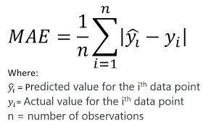
Mean Squared Error (MSE)
Explanation: MSE is the average of the squared differences between the actual and predicted values. Squaring the errors means that larger errors contribute much more to the total error than smaller errors.
Advantages:
Mathematical convenience: The squaring function makes MSE a continuously differentiable function, which is ideal for mathematical optimization techniques like OLS and Gradient Descent.
Penalizes large errors: Gives more weight to larger errors, which can be desirable in cases where large errors are particularly problematic.
Disadvantages:
Units are squared: The resulting value is in squared units of the dependent variable (e.g., "dollars squared"), which can make it harder to interpret directly.
Sensitive to outliers: Outliers (data points far from the line) contribute disproportionately to the MSE, potentially skewing the overall error measure.

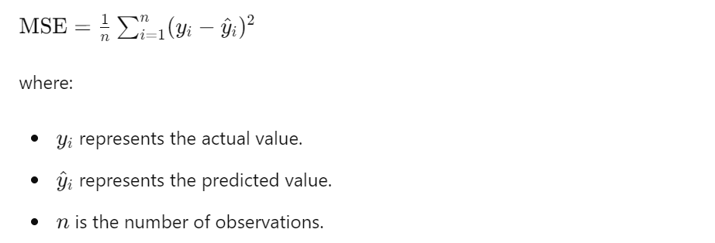

Root Mean Squared Error (RMSE)
Explanation: RMSE is the square root of the MSE. It brings the error measure back to the original units of the dependent variable, making it more interpretable than MSE.
Advantages:
Interpretable units: Like MAE, it is in the same units as the dependent variable, making it easier to understand.
Commonly used: Widely adopted in many fields, allowing for easy comparison across different models and studies.
Disadvantages:
Sensitive to outliers: Inherits the sensitivity to outliers from MSE, as it's directly derived from it.
Can be misleading: If the errors are not normally distributed, or if there are significant outliers, RMSE might not fully represent typical error.
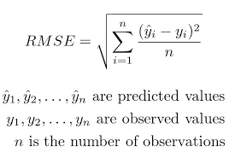

Assumtion of linear Regression

Follow that link -

https://github.com/adas754/ML_Foundations/blob/main/linear_regression_assumptions.ipynb

What is R-squared?
R-squared or the coefficient of determination, is the statistical measure of the variance of the regression (best fit) line from the actual data points. In a generalized linear regression model the model accuracy ranging from 75 - 95% is considered as a good prediction model, whereas 100% accuracy means overfitting.
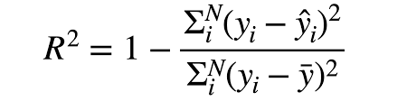
where,
- Numerator is sum of squares of the residuals (the difference between the observed and predicted values).
- and Denominator is is the total sum of squares (the variance of the observed data).

R-Squared Goodness Of Fit
R-square is a comparison of the residual sum of squares (SSres) with the total sum of squares(SStot). The total sum of squares is calculated by summation of squares of perpendicular distance between data points and the average line.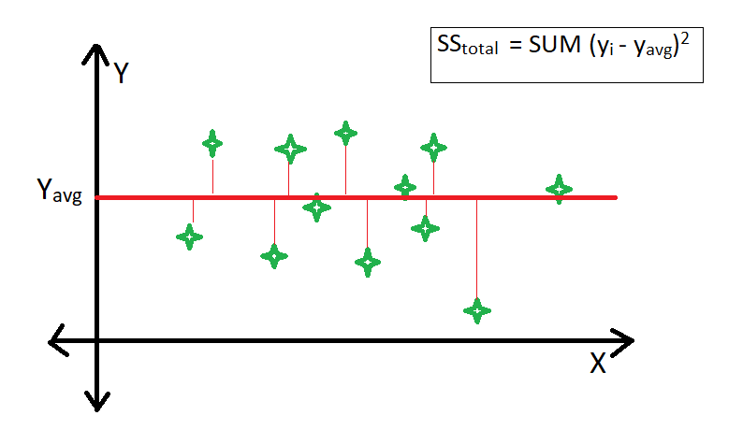
The residual sum of squares is calculated by the summation of squares of perpendicular distance between data points and the best-fitted line.
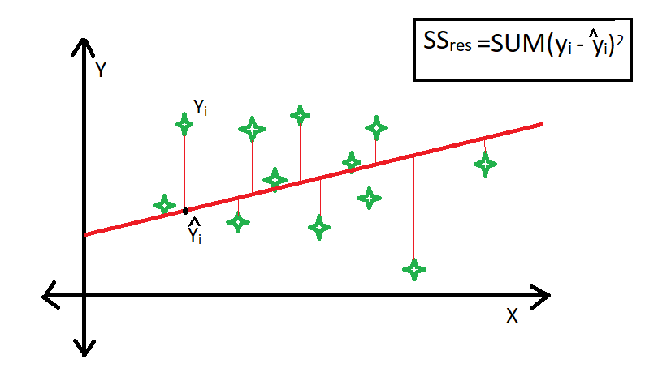

R-squared values range from 0 to 1:
- An R-squared of 0 indicates that the model explains none of the variability of the dependent variable.
- An R-squared of 1 indicates that the model explains all the variability of the dependent variable.
For example, an R-squared value of 0.85 suggests that 85% of the variance in the dependent variable can be explained by the independent variables in the model.

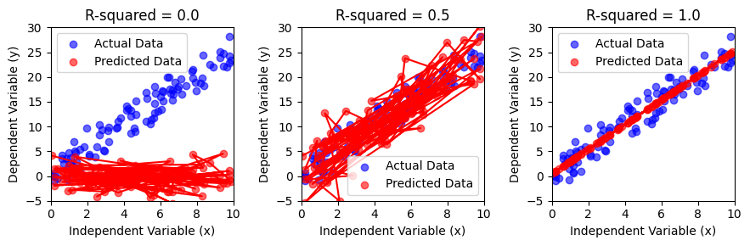
- R-squared = 0.0: The predicted points are randomly scattered, indicating the model has no predictive power. The independent variable (x) does not explain any variation in the dependent variable (y).
- R-squared = 0.5: The predicted points show a moderate relationship with the actual data. The model explains some variation in y, but a lot remains unexplained.
- R-squared = 1.0: The predicted points perfectly align with the actual data, indicating a perfect fit. The independent variable explains all the variation in y.
Summary: R-squared quantifies how well a model fits the data. Higher values indicate a better fit, while lower values suggest the model is less effective.

Limitation of using the R-square method -
- The value of r-square always increases or remains the same as new variables are added to the model, without detecting the significance of this newly added variable (i.e. the value of r-square never decreases on the addition of new attributes to the model). As a result, non-significant attributes can also be added to the model with an increase in the r-square value.
- This is because SStot is always constant and the regression model tries to decrease the value of SSres by finding some correlation with this new attribute hence the overall value of r-square increases, which can lead to a poor regression model.

R-Squared Vs Adjusted R-Squared
Adjusted R-Squared is an updated version of R-squared which takes account of the number of independent variables while calculating R-squared. The main problem with R-squared is that the R-Square value always increases with an increase in independent variables irrespective of the fact that where the independent variable is contributing to the model or not. This leads to the model having high variance if the model has a lot of independent variables.
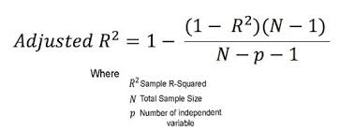

Practical Implementation

https://github.com/adas754/ML_Foundations/blob/main/Project_8_Car_Price_Prediction.ipynb

